**First Increment**

**S-Board**

Submitted

by

Jaya Sai Krishna Muppalla Naveen Kumar Miryala

Krishna Chaitanya Nalluri Sai Rahul Pavuluri

Implementation of services:

1. Built a chat application locally
2. Using the proprofs made a quiz which gives the result after completing the quiz
3. Using proprofs In class teaching materials are uploaded
4. User registration and login page are created with validations.

**System Architecture and frame work specifications:**

We are planning to make our system which has a simple GUI and it has three major people like students as users, Teaching assistants, Professors as administrators. The students are added by the professors and a particular doubt raised by the person can only be closed by that person and giving the feedback of the answer most helpful given by the fellow students. Professor takes the attendance and pop up quizzes. If a doubt is left uncompleted then it can be forwarded to the teaching assistant or the professor.

Activity Diagram:

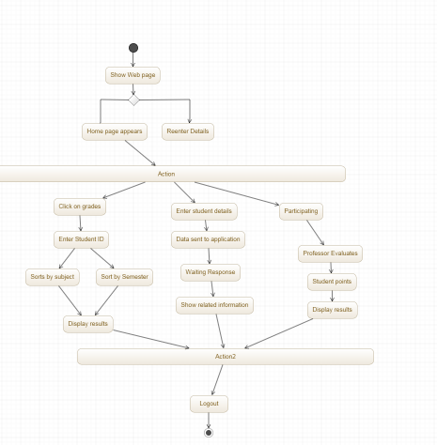

Use Case Diagram:

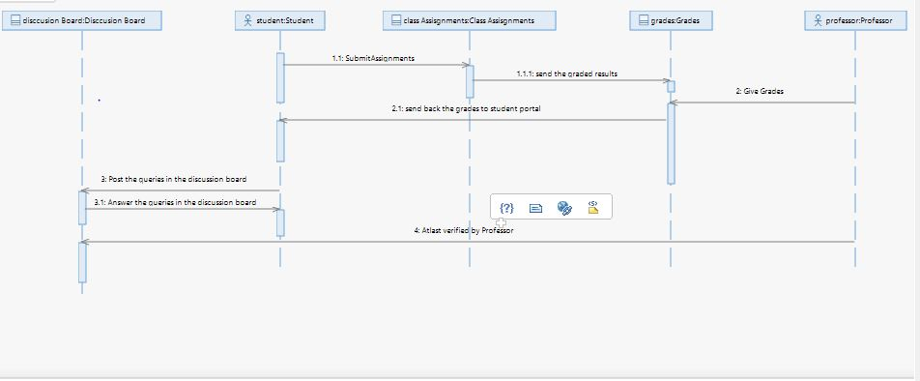

Class Diagram:

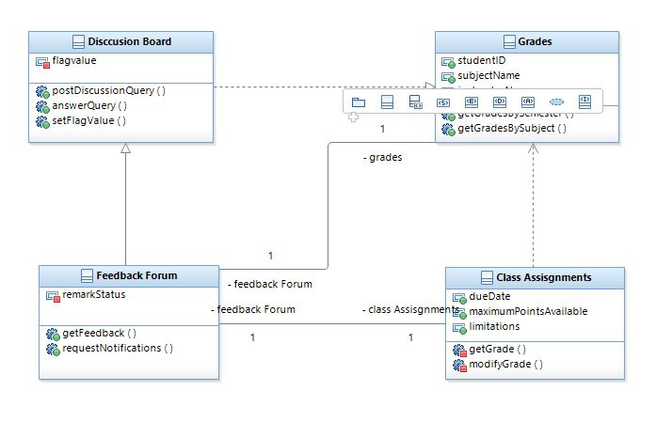

Use Case Diagram:

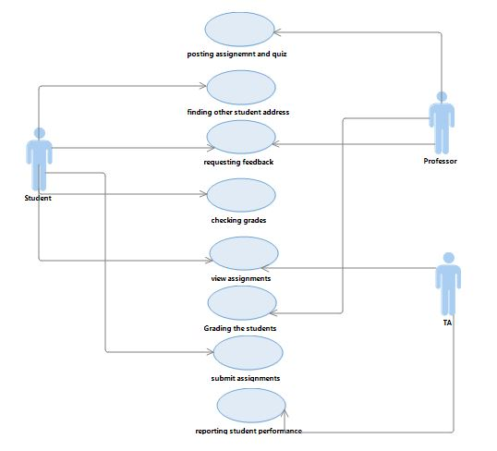

Scrumdo link: <https://www.scrumdo.com/projects/project/project1102/summary>

Github link: https://github.com/jmmvd/ase-project

Screen shots :

Registration page

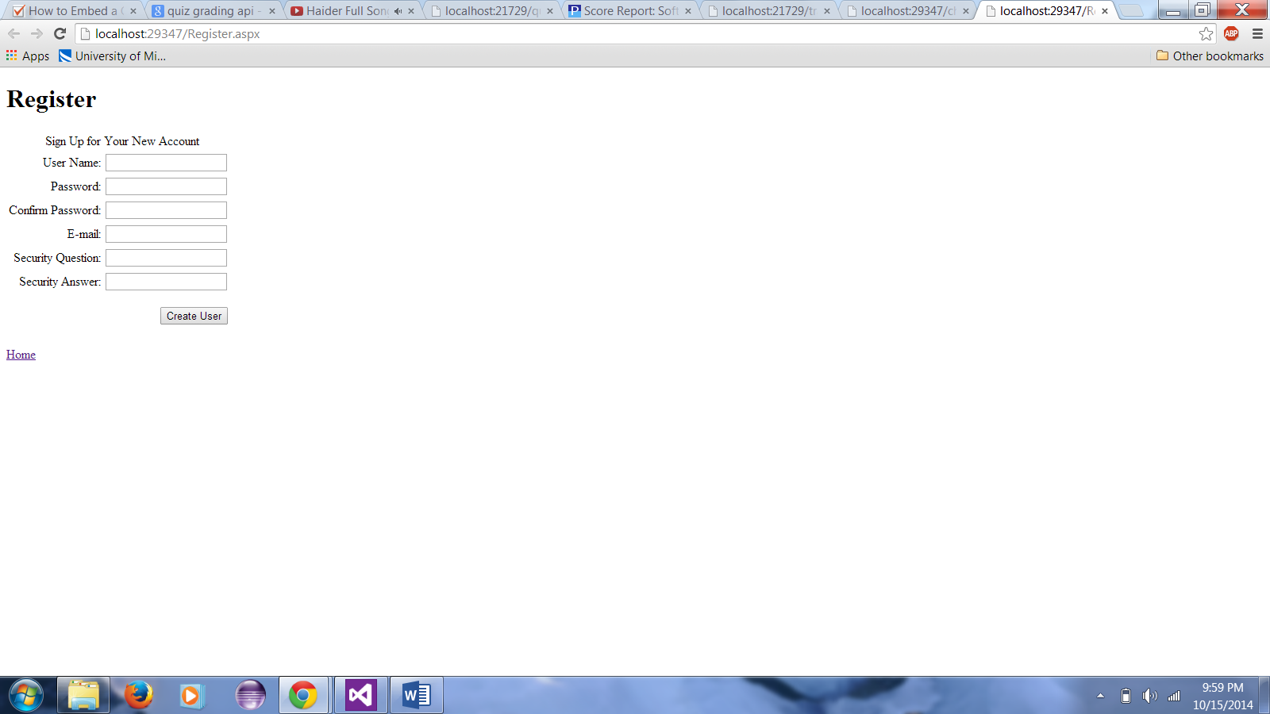

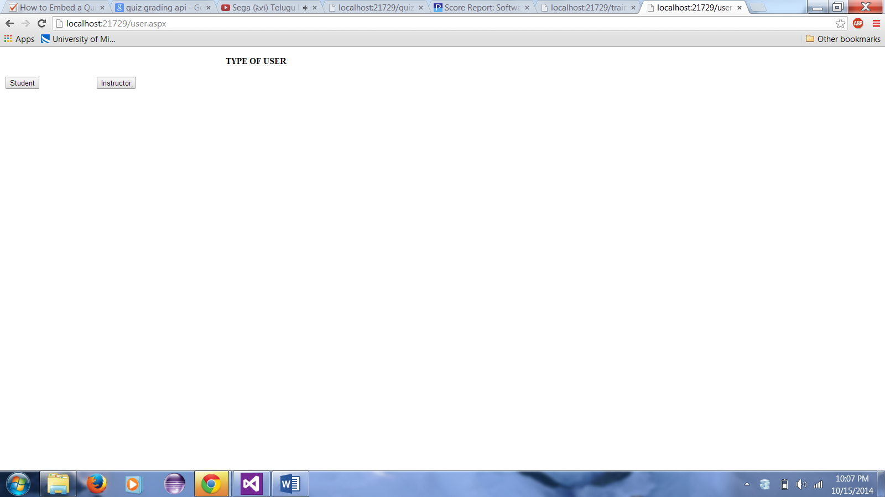

Login

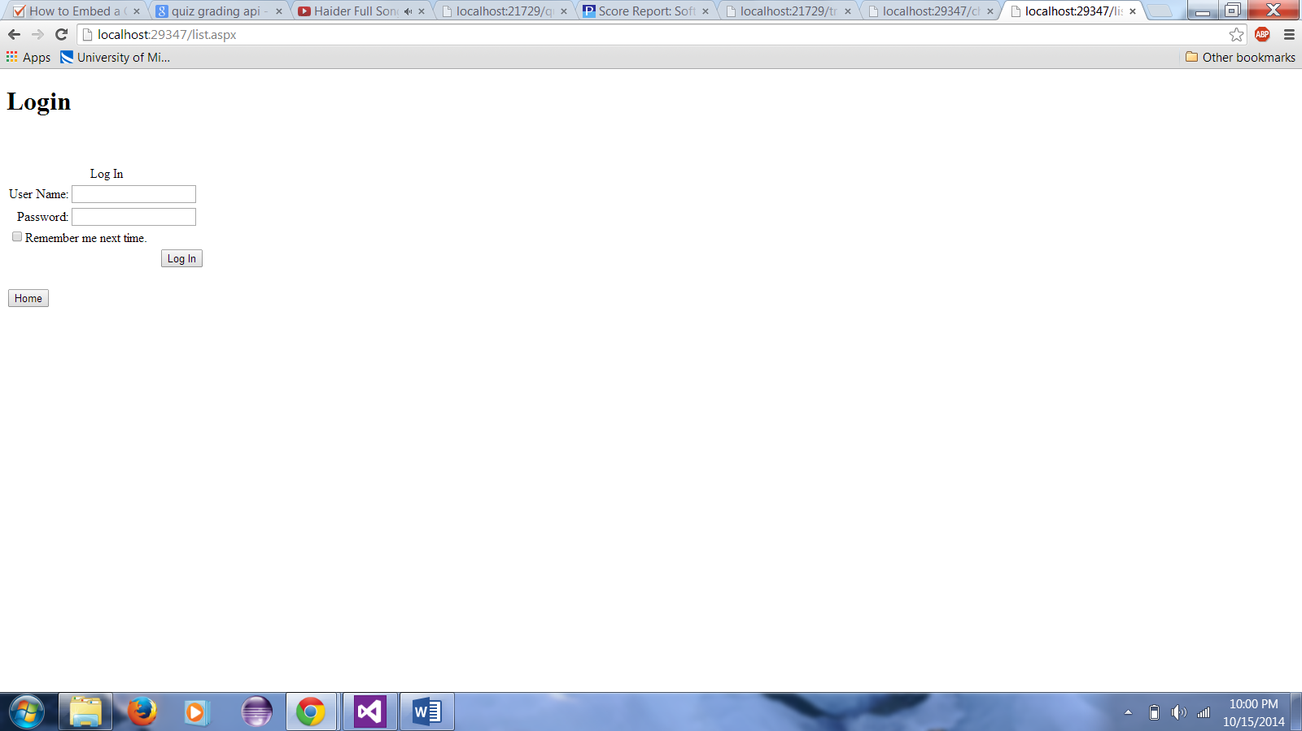

Chat

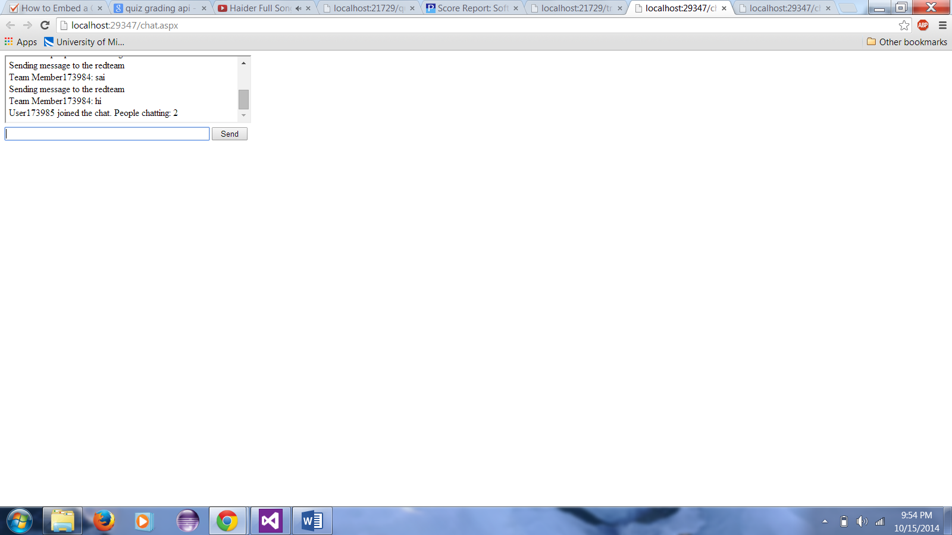

Training

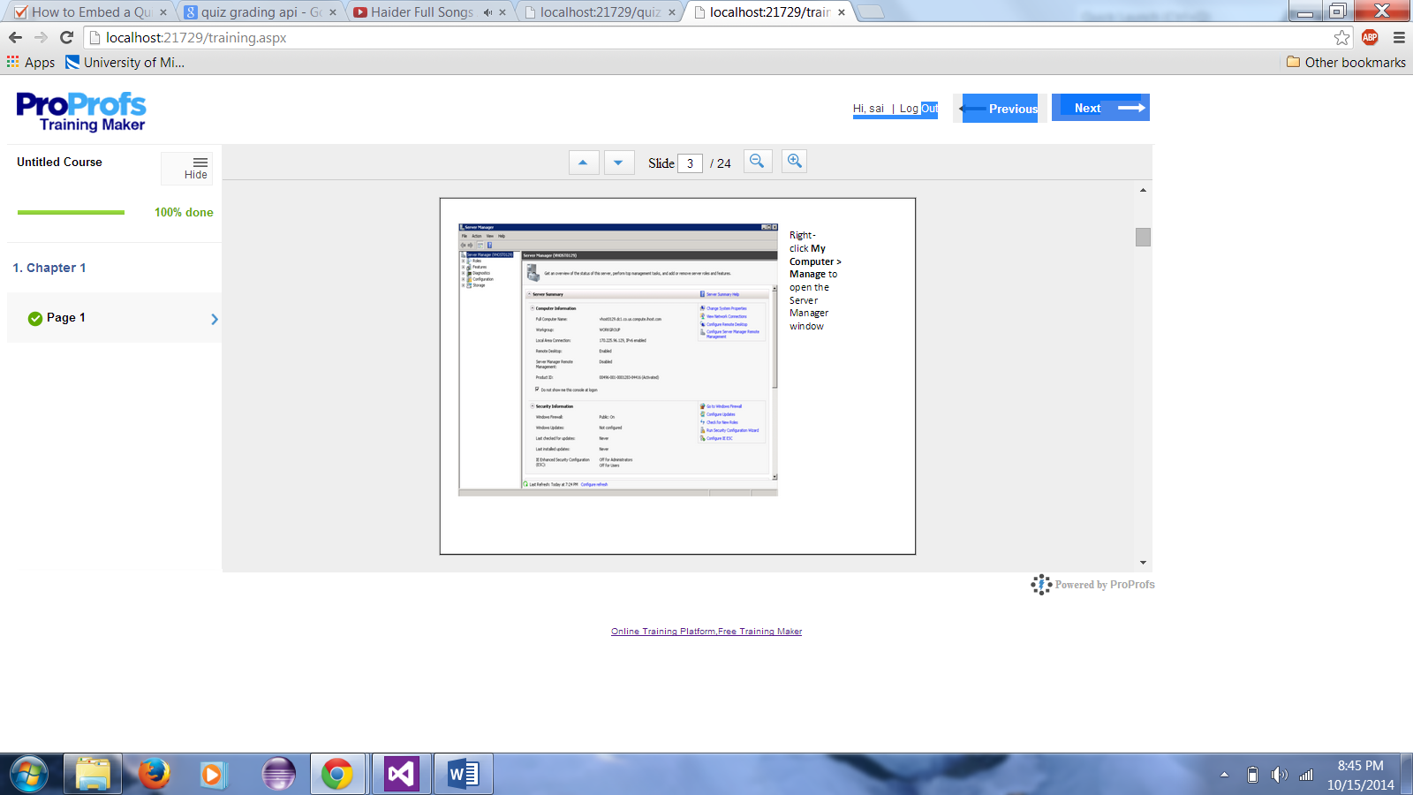

Quiz

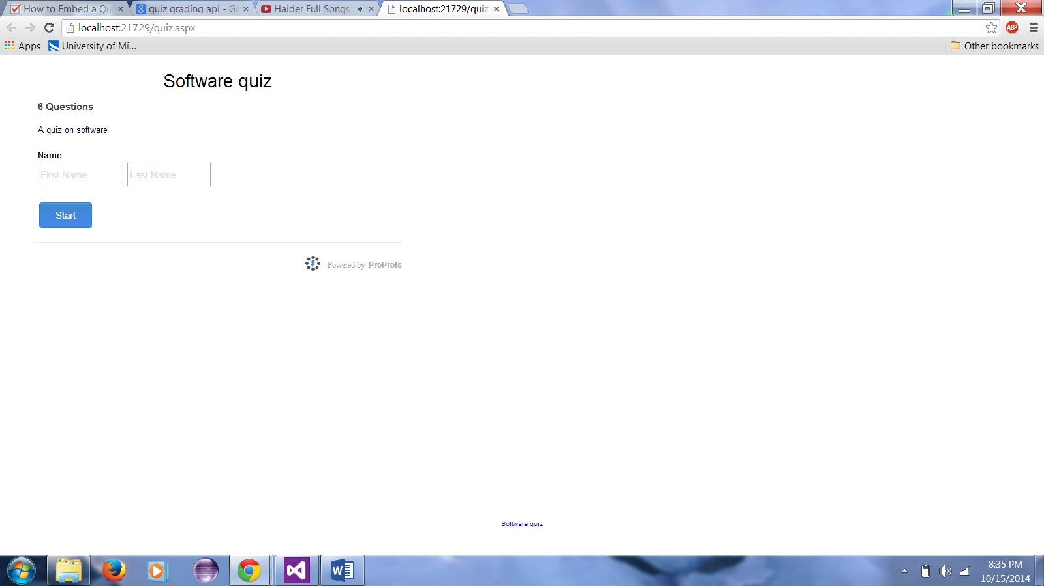

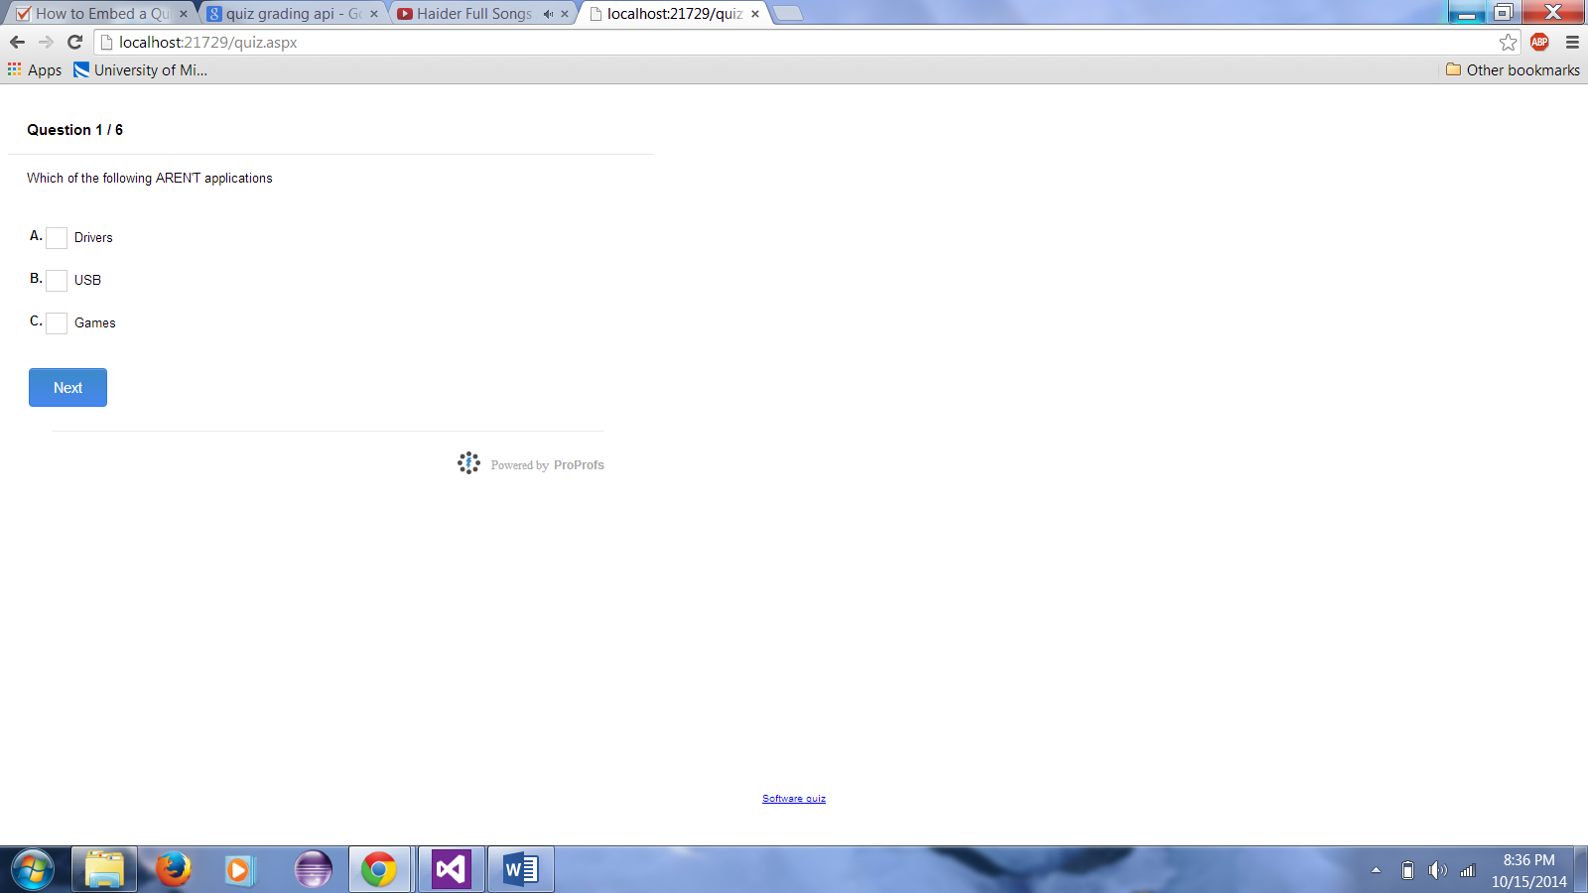

**Project Management:**

We have equally distributed the work among the four members and had equally contributed the workload.

**Second Increment:**

1. Deploying the chat application in the cloud and make sure the correct functionality is achieved.
2. Making group chats
3. Deploying the quiz task in the cloud so that when the instructor post the quiz all the students can answer them and submit accordingly.
4. Taking attendance by verifying the current location of the student.
5. Making threads for the discussion among the students who post their doubts.
6. Integrating google chart to evaluate student in-class performance.